## Development of DFT model for Amorphous MCM-41 support for metathesis catalysts The aim of this project is to develop a model that could be used to create the three surfaces identified in MCM-41 support material.

# P Geldenhuys, 10800662

## Summary

Ruthenium based olefin metathesis catalyst systems finds very broad application in various industries including pharmaceutical, biotechnology and in the synthesis of speciality polymers. Historically these catalyst systems have been homogenous, leading to high complexity and cost of recovery and regeneration. Industry and research institutions have identified various mesoporous silica materials which could be used as solid supports for the heterogenization of the catalyst systems. The heteregenous catalyst system consists of a catalyst adsorbed or bonded to the surface of the amorphous mesoporous. In order for the catalyst to effectively adsorb or bond to the surface an amorphous mesoporous surface is required with a homologous pore distribution and narrow pore size distribution. The work presented here is a preliminary study into the modelling of the amorphous silica surface for use in the creation of a heterogenous catalyst system.

The aim of this study is to develop a realistic model for rendering alpha quartz amorphous for use as solid mesoporous support for the Grubbs type metathesis catalysts. This model will support parallel laboratory work in the research group focussed on the development of a heterogenous alkene metathesis catalyst system.

Density Functional Theory and Molecular Dynamics modelling of the annealing process of alpha quartz will be performed using Material Studio®*(1)ref))* molecular modelling software. The results generated will be used to determine optimal conditions for rendering the starting material amorphous and to compare the results with existing practical and molecular modelling results available in literature

## Introduction

One of the most widely researched and published topics in chemistry in the past two decades is the development of new applications and catalysts for olefin metathesis. *(2J W Herndon, New Mexico State University, Las Cruces, NM, USAª 2007 Elsevier Ltd.)*

The metathesis reaction involves the cleavage of an alkene carbon-carbon double bond followed by the rearrangement of the alkylidene products to form a product alkene. (*Figure 1)*

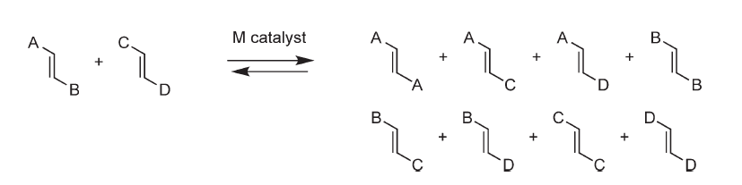

Figure 1

A wide variety of categories of metathesis reactions have been identified. The variety shown in (Figure 2) is not exhaustive, but gives an idea of how versatile this family of reactions are. (*1.06 Metathesis ReactionsJ W Herndon, New Mexico State University, Las Cruces, NM, USAª 2007 Elsevier Ltd.*)



*Figure 2.*

Because of this versatility, the olefin metathesis reaction has found wide-spread application in laboratories for the synthesis of unique polymers and research into the synthesis of a wide variety of molecules.[3] The reaction has led to major advancements in various industries including the synthesis of natural products, pharmaceuticals, nanomaterials, speciality polymers and the biotechnology industry for the synthesis of steroids and other biological molecules *(4,5,6)*

The currently accepted mechanism of olefin metathesis, the Chauvin mechanism*(7)*, involves reversible cycloaddition steps involving alkenes and carbene complexes. Metal-carbene complexes have thus become the most prominent category of catalysts for olefin metathesiscarbene . The Mo based Shrock-catalyst showed high reactivity, but proved to be unstable in certain conditions. This drawback was overcome by the invention of a Ruthenium-Carbene complex catalyst. is.*8* Research efforts by various groups has led to several variants of the Grubbs catalysts being developed *(Figure 3)*, each generation improving and expanding on the application of these systems. This has made these catalysts the most widely used and versatile of all the metathesis catalysts available to the industry and research community.[3,9]

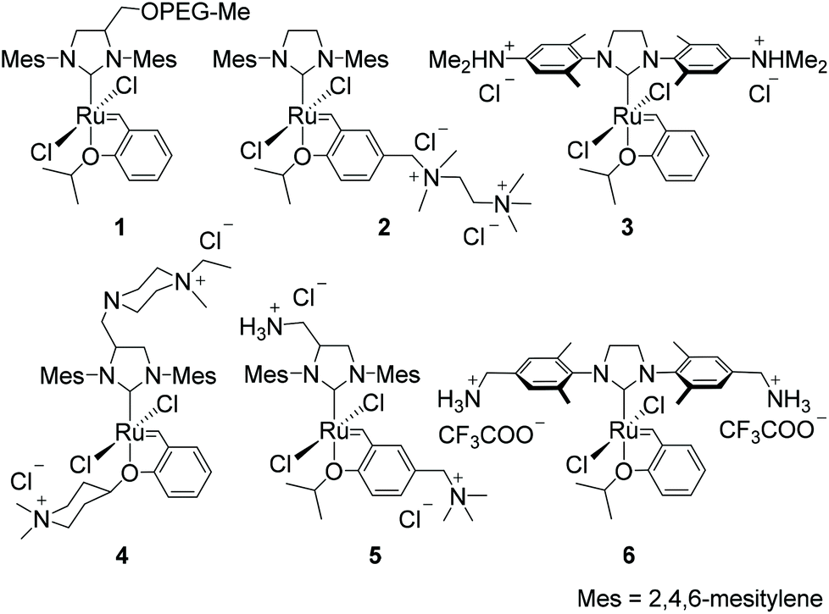

Figure 3

The catalyst systems currently in use are mostly homogenous systems and this creates challenges when catalysts need to be recycled and reused. Homogenous systems are also prone to contamination of the reaction product with ruthenium by-products, this is one of the major drawbacks of these catalytic systems for application in the pharmaceutical industry. (*14,15)*

A drawback of the heterogenization of the catalyst system is that decreased catalytic activity is observed. Despite this decreased activity, the increased application The heterogenization of the catalysts is accomplished by adsorbing or supporting the catalyst on a support material that does not significantly impact on the reactivity of the catalyst.

These challenges have led to various groups initiating studies for the development of heterogenous catalytic systems based on the Grubbs catalysts. These studies have identified several materials as possible solid supports for the catalysts. In particular the MCM-41 group of amorphous silica materials have caught the attention as support materials. This is due to the homologous pore distribution and narrow pore size distribution of these materials.*(16)*

The project will focus on the molecular modelling of MCM-41 hydroxylated amorphous Silica surfaces [12,13]. This project will support a parallel molecular modelling study of the structure and bonding of the Grubbs group of catalysts to the SBA-15 hydroxylated silica surfaces. The properties calculated in the modelling will be used to predict the optimum conditions for the preparation of an amorphous silica bulk which can be used as

## Aim

The aim of this project is the development of method to creating an amorphous SiO2 bulk structure. And to develop a model that could be used to create the three surfaces identified in MCM-41 support material,

## Method

An alpha quartz (space group 180) crystal structure was obtained from Materials Studio’s structure repository. A (3x3x3) super cell was built. This supercell (bulk) was submitted to an energy calculation. The following properties was calculated for the supercell.

1. Energy
2. Density of states
3. Band Structure
4. Orbitals
5. Bond lengths and bond angles

The next step will be to model a MCM-15 mesoporous surface by creating an amorphous SiO2 bulk. To accomplish this the (3x3x3) super cell created previously has to be submitted to dynamics studies using Materials Studio’s CASTEP module [4, 5].

The dynamics study entailed heating (to create a liquefied sample) the super cell that was created previously to 4000K, 5000K and 6000K respectively, using a NVT ensemble. The heating will be done in 50, 100 and 150 steps with a constant time step of 1 fs using a Nose thermostat. The structure obtained at each temperature was then quenched to 1K in 2 steps with a constant time step of 1 fs using a Nose thermostat. The resulting structures was annealed by heating the resulting structures to 1000 K using the same settings for each structure as that used in the initial heating. The resulting structures was then cooled down to 300 K using the same time step setting as used during the melting step for each structure. This work procedure is outlined in Table 1

|  |  |  |  |  |  |
| --- | --- | --- | --- | --- | --- |
| Calculation 1 |  |  |  | Annealing | |
|  | Melting | Quenching | Annealing | Cooling |
| Temperature (K) | 4000 | 1 | 1000 | 300 |
| Steps | 50 | 2 | 50 | 50 |
| Calculation 2 |  |  |  | Annealing | |
|  | Melting | Quenching | Annealing | Cooling |
| Temperature (K) | 4000 | 1 | 1000 | 300 |
| Steps | 100 | 2 | 100 | 100 |
| Calculation 3 |  |  |  | Annealing | |
|  | Melting | Quenching | Annealing | Cooling |
| Temperature (K) | 4000 | 1 | 1000 | 300 |
| Steps | 150 | 2 | 150 | 150 |
| Calculation 4 |  |  |  | Annealing | |
|  | Melting | Quenching | Annealing | Cooling |
| Temperature (K) | 5000 | 1 | 1000 | 300 |
| Steps | 50 | 2 | 50 | 50 |
| Calculation 5 |  |  |  | Annealing | |
|  | Melting | Quenching | Annealing | Cooling |
| Temperature (K) | 5000 | 1 | 1000 | 300 |
| Steps | 100 | 2 | 100 | 100 |
| Calculation 6 |  |  |  | Annealing | |
|  | Melting | Quenching | Annealing | Cooling |
| Temperature (K) | 5000 | 1 | 1000 | 300 |
| Steps | 150 | 2 | 150 | 150 |
| Calculation 7 |  |  |  | Annealing | |
|  | Melting | Quenching | Annealing | Cooling |
| Temperature (K) | 6000 | 1 | 1000 | 300 |
| Steps | 50 | 2 | 50 | 50 |
| Calculation 8 |  |  |  | Annealing | |
|  | Melting | Quenching | Annealing | Cooling |
| Temperature (K) | 6000 | 1 | 1000 | 300 |
| Steps | 100 | 2 | 100 | 100 |
| Calculation 9 |  |  |  | Annealing | |
|  | Melting | Quenching | Annealing | Cooling |
| Temperature (K) | 6000 | 1 | 1000 | 300 |
| Steps | 150 | 2 | 100 | 100 |

Using a GGA-PBE functional and DNP basis set, the system energy, as well as the following properties was calculated for each result set (structure)

* + Energy
  + Bond lengths and bond angles
  + Density of states
  + Band structure
  + Electron density difference
  + Orbitals

The results obtained for the amorphous structure was compared to the values for the initial crystal structure as well as published experimental and theoretical data

## Results and discussion

Result files from the Material Studio software were downloaded and interpretted.

The energy values for the various steps of the simulation was plotted and is shown in

Chart 1.

The energy evolution for the specific temperature conditions are shown Charts 2-4

## C:\Users\10073817\Desktop\Pieter Geldenhuys\Band Gap Quenching.png

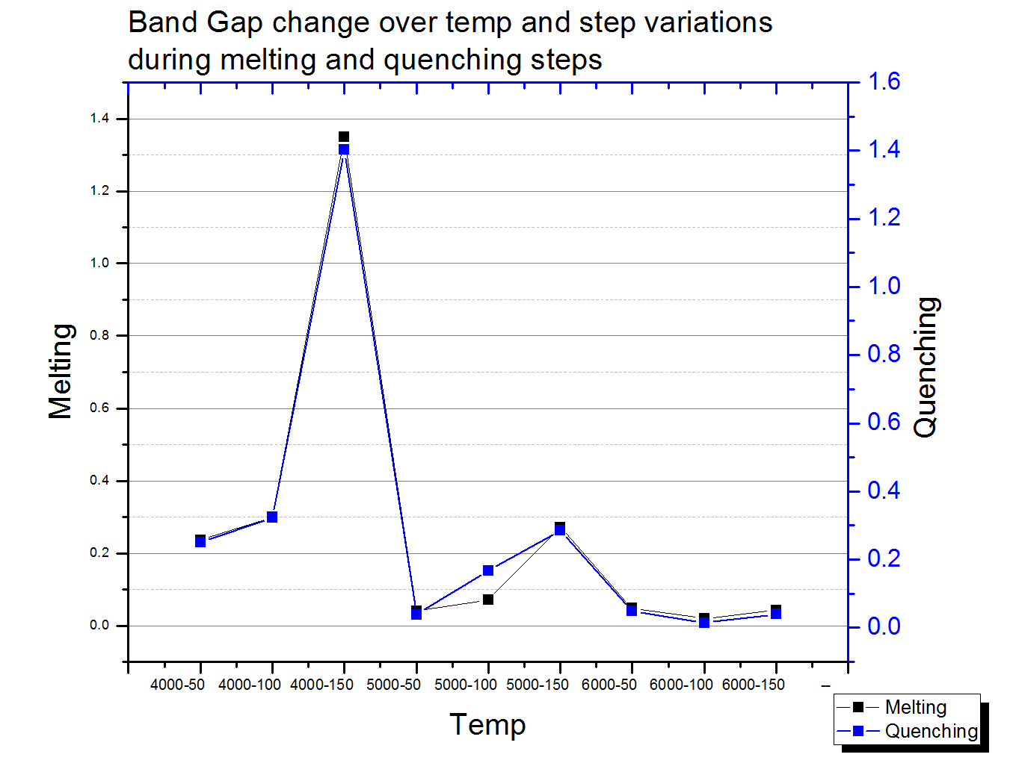

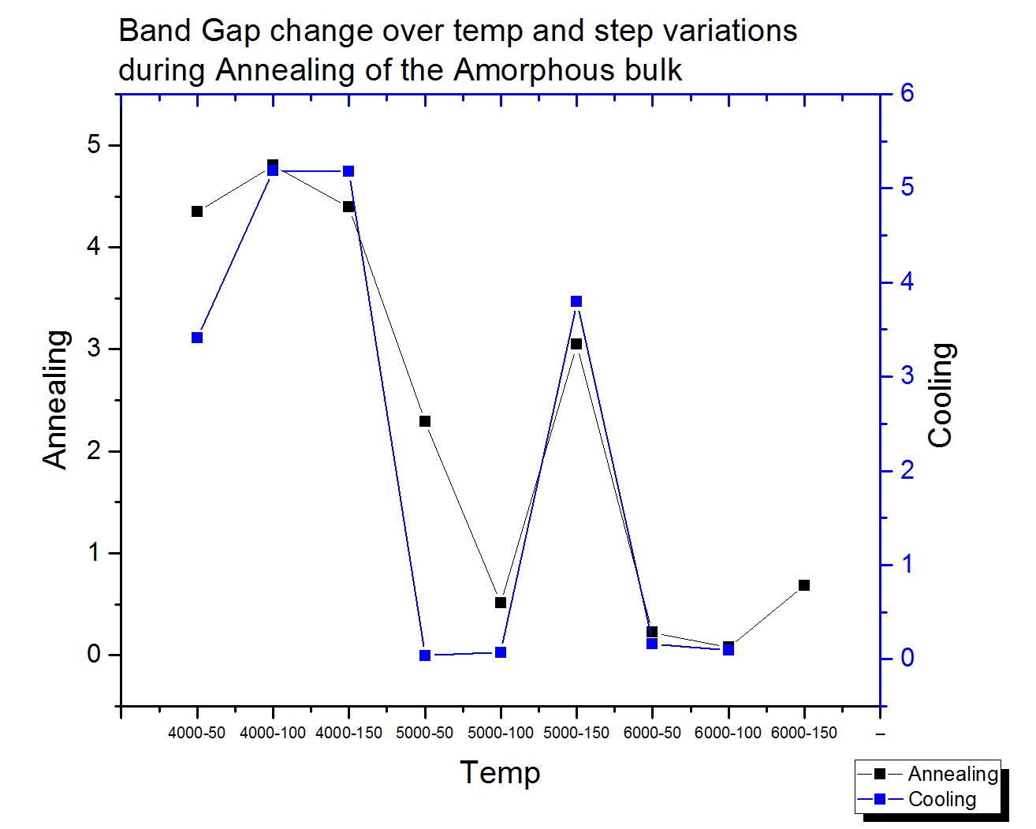

## Conclusion

References

1. Material Studio ref
2. J W Herndon, New Mexico State University, Las Cruces, NM, USAª 2007 Elsevier Ltd.
3. Jordaan, M., *Experimental and Theoretical investigation of New Grubbs-type Catalysts for the Metathesis of Alkenes.* p. 413.
4. Zukowska, Szadkowska, Grela,.
5. Metathesis hydrogenation of natural rubber latex Suwadee Kongparakula, Flora T.T. Ngb, Garry L. Rempelb
6. Application of olefin metathesis in the synthesis of steroids,Jacek W. Morzycki
7. Herrison, J. L.; Chauvin, Y. Makromol. Chem. 1971, 141, 161–176
8. Grubbs, Tetrahedron, 60, 2004
9. Kotha, Dipak, Tetrahedron 68, 2012
10. Thielemann, J.P., et al., Pore structure and surface area of silica SBA-15: influence of washing and scale-up. Beilstein J. Nanotechnol, 2011. 2: 110-8.
11. Balcar, H. and J. Čejka, Mesoporous molecular sieves as advanced supports for olefin metathesis catalysts. Coord. Chem. Rev., 2013. 257: 3107-3124.
12. Izumi, S., et al., Classification of amorphous-silicon microstructures by structural parameters: molecular dynamics study. Comput. Mater. Sci., 2004. 31: 258-268.
13. Ugliengo, P., et al., Realistic models of hydroxylated amorphous silica surfaces and MCM-41 mesoporous material simulated by large-scale periodic B3LYP calculations. Adv. Mater., 2008. 20: 4579-4583.
14. *Journal of Molecular Catalysis A: Chemical 372 (2013) 35– 43*
15. *Microporous and Mesoporous Materials 175 (2013) 170–177*
16. *Catalysis Today 179 (2012) 123– 129*